

**AWS Lab #3**

**By Diego Santos**

**Intro**

Today we’ll be setting up and configuring an Amazon EC2 instance which will be used like a webserver.

**Screenshots**

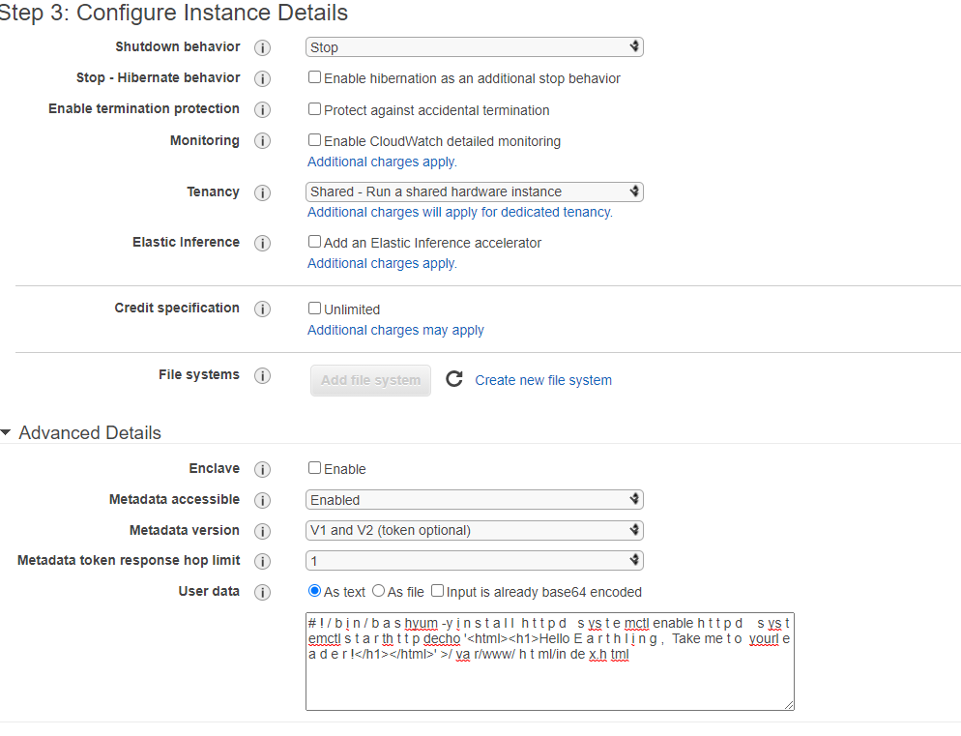

(Configuring the settings of the EC2 instance)

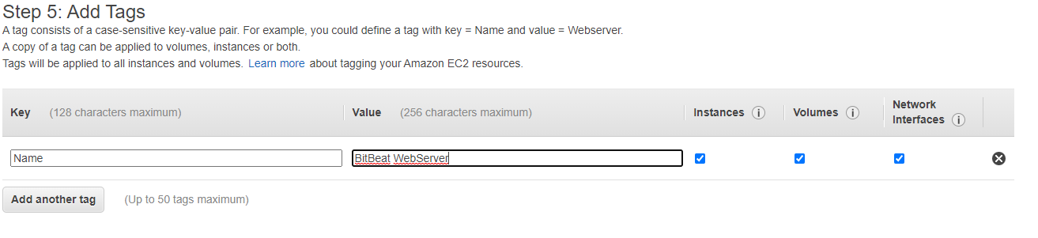

(Adding tags)

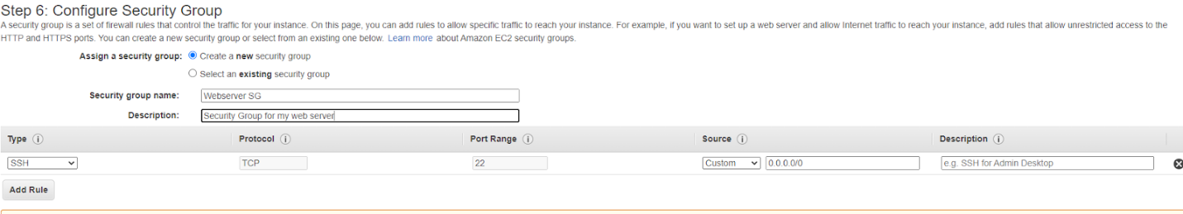

(Creating Security Group)

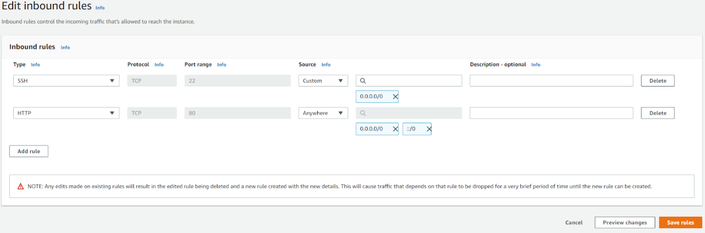

(Creating inbound rule)

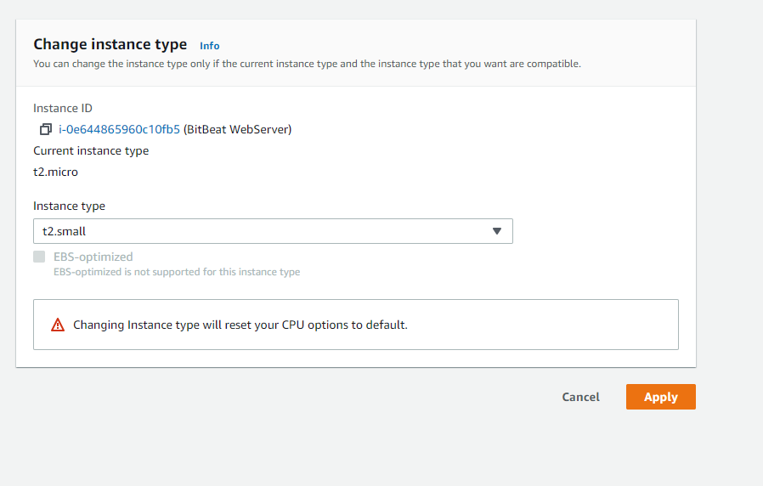

(Changing Instance Type)

**Problems**

I did not run into any problems while performing this lab